Introduction to Signal and Image Processing

Lab 1
In this assignment, I worked with the following picture:
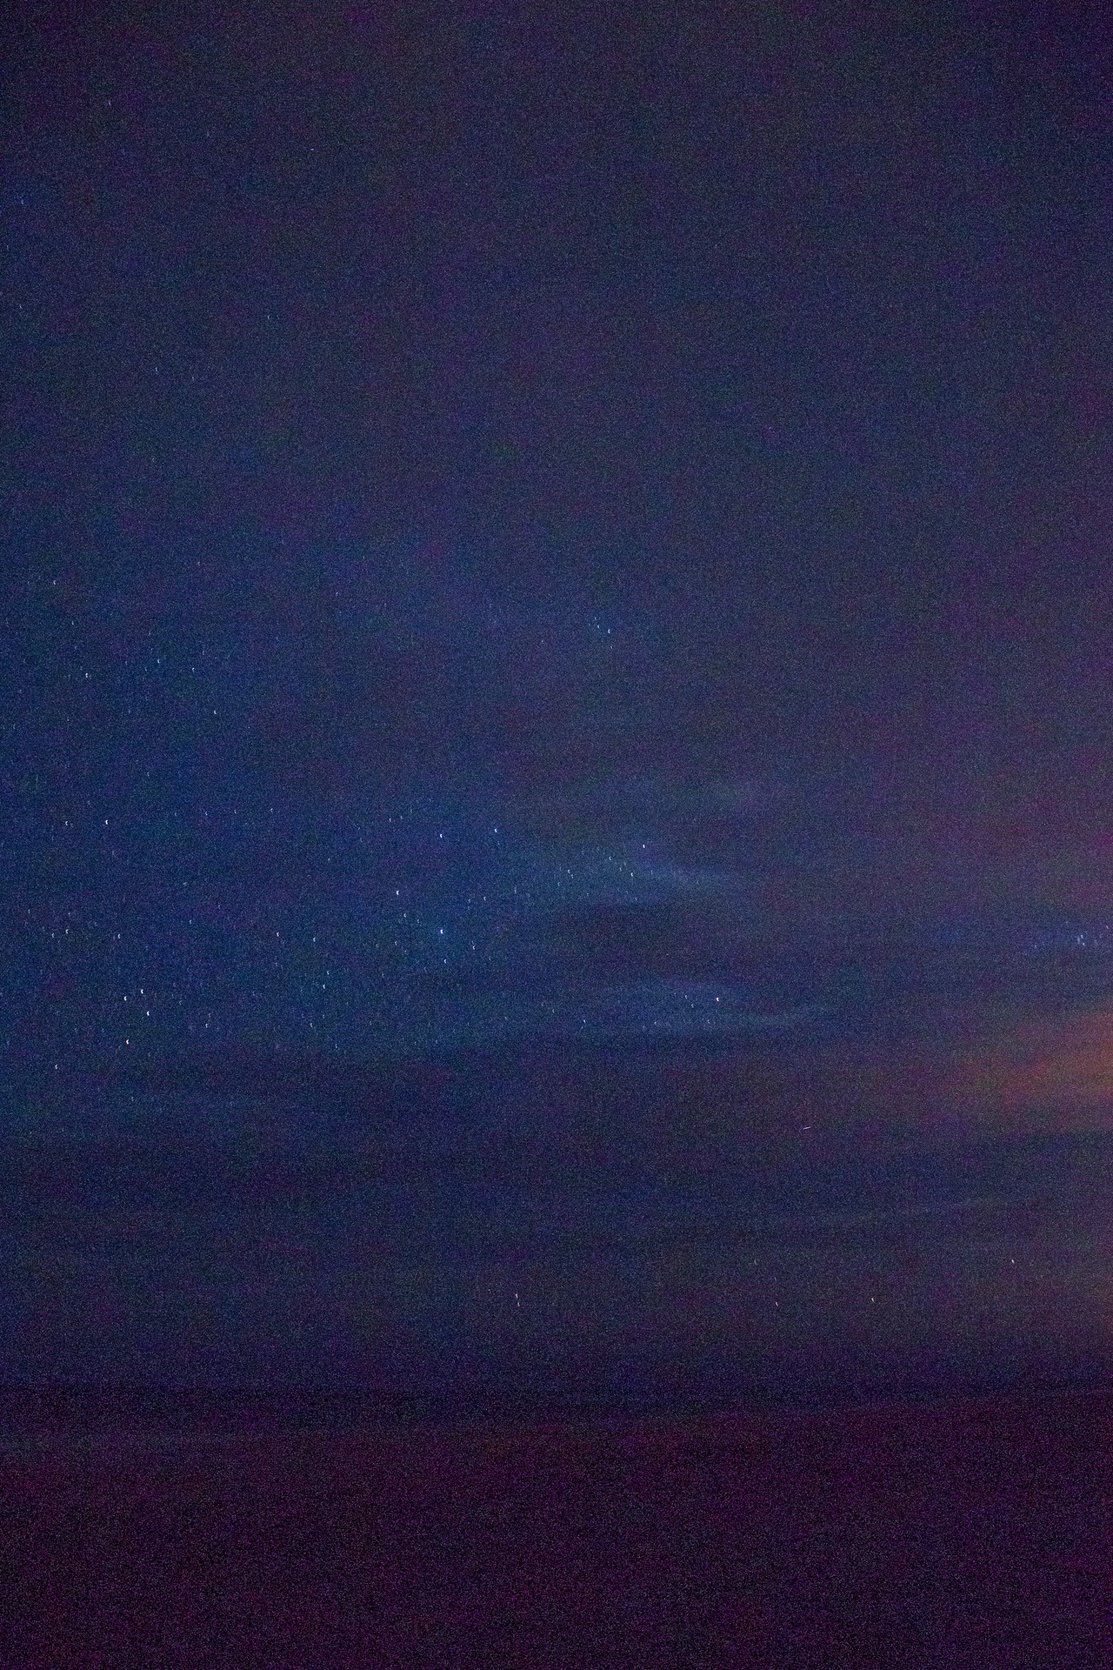
This picture has two major flaws that will be corrected in the exercise.
For one it is clearly very noisy. Since it is a randomly distributed noise, I tried to use two filters to correct that image. The first was a average filter. Unfortunately, the noisy parts are so big that the neighborhood has to be around 10x10 pixels, which makes the picture very blurry. So in the end I used a Gaussian filter.
fspecial('gaussian',[10 10],100);

The Gaussian filter is very well adapted to random noise, but it blurs the image. In this example, however, blurring isn't that critical since there aren't any clear edges anyways, The only exception are the stars in the middle of the picture.

The second modification is to stretch the contrast. The picture is severely underexposed, as seen in these before and after histograms of the picture in HSV space. I use stretchlim(smoothImage, [.03 .97]); to get the limits for imadjust, but leave the hue channel on 0, 1 to not change the colors too much. I also saturated the outermost values to get a bit of a better picture out.
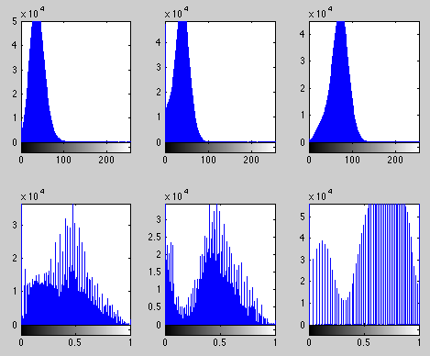
Afterwards I just make a small adjustment to the gamma, since the lower values are still a bit too strong in the picture, especially the bottom of the picture would be pitch black.

The result of this transformation:
